Ambekeshwar Group Of Institutions



Technology & Management, Lucknow

**Session: 2023-24**

Practical File

# **Branch:- CSE 2nd Year | 3rd Sem**

**Subject:- Internet and Web Technology**

# **Name:- Suraj Arya**

# **Date:-**

Name Signature

Subject Teacher Miss. Fiza Hussain …………………………..

Class Co-Ordinator Miss Fiza Hussain …………………………..

Head of Department Miss. Richa Mishra …………………………..

Academic Co-ordinator Mr. Shivanshu Singh …………………………..

INDEX

|  |  |  |  |  |
| --- | --- | --- | --- | --- |
| **S. no.** | **Name of Exp.** | **Date** | **Subject**  **Teacher**  **Sign** | **Academic**  **Co-Ordinator**  **Sign** |
| 1. | Creating web pages using different HTML tags. | 15/Sep/2023 |  |  |
| 2. | Install, Configure and start using developer tools/code editor/browser. | 22/Sep/2023 |  |  |
| 3. | Control the look and feel of web pages styling of using CSS. | 20/Oct/2023 |  |  |
| 4. | Write JS Function and control the different components of webpage by predefined JS Object. | 27/Oct/2023 |  |  |
| 5. | Use Jquery library to apply different features on web pages. | 3/Nov/2023 |  |  |
| 6. | Use Bootstrap library and icons to develop a responsive websites. | 17/Nov/2023 |  |  |

**Practical No: 1**

**AIM :** Creating web pages using different HTML tags.

# **Set Up Your Environment:**

# Before you begin, you'll need a text editor to write your HTML code. Popular choices include Visual Studio Code, Sublime Text, or Notepad (for Windows users).

1. **Create a New HTML File:**

Open your text editor and create a new file with a .html extension. You can name it whatever you like, but for this example, let's call it index.html.

1. **Basic Structure:**

Every HTML document starts with a basic structure. Here's the minimal template:

<!DOCTYPE html>

<html lang="en">

<head>

    <title>Document</title>

</head>

<body>

    <!-- Your Content goes here -->

</body>

</html>

**<!DOCTYPE html>**: This declaration defines the document type and version.

**<html>** : The root element that wraps all the content.

**<head>** : Contains metadata about the document, such as the title.

**<title>** : Sets the title of your web page, which appears in the browser's tab.

**<body>** : Contains the visible content of your web page.

1. **Adding Content:**

You can add various types of content within the <body> element:

* 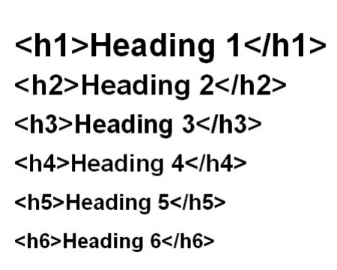**Headings:**
* **Paragraph**

<p>This is a Paragraph</p>

* **Image**

<img src="image.jpg" alt="description of the image">

* **List:**

<ul>

    <li> Item 1 </li>

    <li> Item 2 </li>

</ul>

## Links

<a href="https://www.instagram.com/officialsurajarya/">Suraj Arya</a>

1. **Save Your File:**

Save your file with Extension .html

1. **View in a Web Browser:**

Open your web browser and navigate to the file you just created. You can do this by using "File" > "Open File" selecting your index.html file. You should see your basic web page with the content you added.

1. **Further Learning:**

HTML is a versatile language, and there's much more to learn, such as CSS for styling and JavaScript for interactivity. As you become more comfortable with HTML, you can explore these topics to enhance your web page.

**Creating Web Page Using HTML**

<!DOCTYPE HTML>

<html>

<html lang="en">

<head>

    <meta charset="UTF-8">

    <meta name="viewport" content="width=device-width, initial-scale=1.0">

    <title>Document</title>

    <STYLE>

        li {

            COLOR: rgb(67, 206, 7);

        }

    </STYLE>

</head>

<body>

    <CENTER>

        <h1>

            </p><i> <b> BAZAR VILLAGE</b></i></h1>

    </CENTER>

    <CENTER> <U> A trendy online shopping</U></CENTER>

    <h2><b>For our best and trendy products click the links</b></h2>

    MENS WEAR <a href=“flipkart .com ">CLICK</A>

<br>

WOMEN wear<a href=" https://www.myntra.com/dresses">click</a>

    <br>

    <h3> reason to shop with us </h3>

    <ul type="star">

        <li>we always try to give you best</li>

        <li>we always find best deal for you</li>

        <li>all the sites are trusted</li>

        <li>all sites are persnally check</li>

        <li> all discount and offers are same as on site</li>

        <li>other copons are available</li>

        <li>all the products are deliverd by companies </li>

        <li>all the T& are same as on site </li>

    </ul>

    <br>

    <h4>OUR PARTNER WEB SITES</h4>

    <table>

        <TR>

            <TH>FLIPKART</TH>

            <TH>MYNTRA</TH>

        </TR>

        <TR>

            <TD>flipkart.com</TD>

            <TD>myntra.com</TD>

        </TR>

    </table>

</body>

</html>

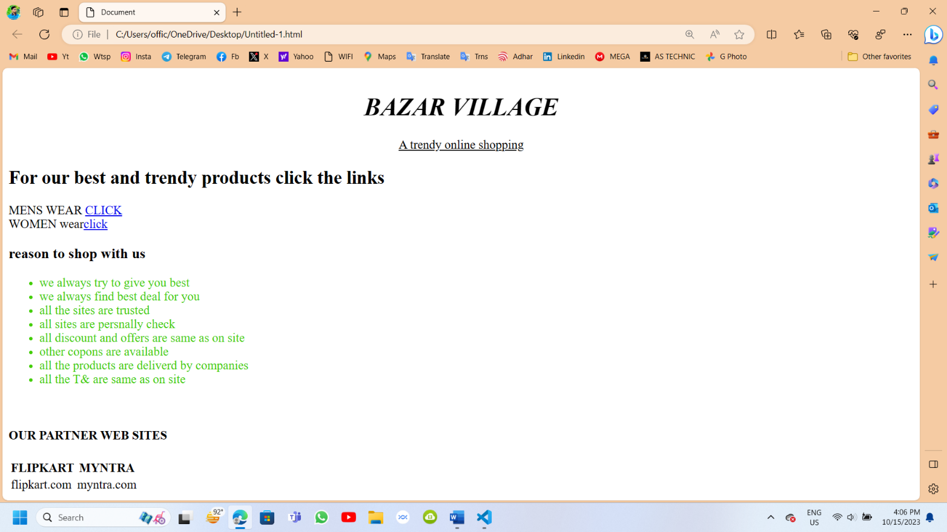**Output**

**Practical No: 2**

**AIM :** Install, Configure and start using developer tools/code editor/browser.

**Overview**

This project will walk you through the process of installing, configuring, and effectively using essential developer tools, a code editor, and a web browser. These tools are vital for web development and coding tasks, and understanding how to set them up and use them is essential for developers and programmers.

1. **Introduction**

In this project, i will guide you through the installation, configuration, and usage of essential developer tools, a code editor, and a web browser. These tools are crucial for web development and coding, and by the end of this guide, you'll have a solid foundation to work effectively.

1. **Setting Up a Code Editor**

## **Choose a Code Editor**

Before getting started, you need to choose a code editor that suits your needs. Popular options include Visual Studio Code, Sublime Text, and Atom. Choose one that aligns with your preferences.

## **Installation**

#### **Windows**

Download the installer for your chosen code editor. Run the installer and follow the installation wizard.

* **macOS**

Download the macOS version of the code editor. Drag the application to your Applications folder.

* **Linux**

Depending on your distribution, use the appropriate package manager (e.g., apt, yum, or dnf) to install the code editor.

## **Configuration**

## Open your code editor and explore the settings/preferences.

* Customize the editor by selecting a theme, configuring code formatting, and setting up code extensions that match your programming languages.

### **Utilizing Developer Tools in a Web Browser**

### **Introduction to Developer Tools**

* Understand the significance of developer tools in web development.
* Recognize the key features, including HTML/CSS inspection, JavaScript debugging, and network analysis.
  1. **Accessing Developer Tools**
* In your web browser (e.g., Google Chrome or Mozilla Firefox), open a web page.
* Access developer tools by pressing F12 or Ctrl+Shift+I (Windows/Linux) or Cmd+Option+I (macOS).
  1. **Basic Usage**
* Learn to inspect HTML and CSS elements on a web page.
* Experiment with the JavaScript console.
* Modify and preview changes to HTML and CSS in real-time.
  1. **Debugging and Profiling**
* Use the debugger to set breakpoints and step through JavaScript code.
* Learn how to profile web page performance and identify bottlenecks.
  1. **Network Inspection**
* Explore the network tab to view network requests.
* Analyze requests, response times, and HTTP status codes.

### **Exploring Browser Extensions for Developers**

### **Introduction to Browser Extensions**

* Understand the role of browser extensions in web development.
* Realize how extensions can enhance productivity and streamline tasks.
  1. **Must-Have Developer Extensions**
* Explore essential browser extensions, including AdBlock, uBlock Origin, and Web Developer Tools.
* Understand the benefits and purposes of each extension.
  1. **Installation and Configuration**
* Visit the browser's extension store or marketplace.
* Search for and install the desired developer extensions.
* Configure extension settings to match your workflow.

1. **Conclusion**

By following this step-by-step guide, you will have successfully installed, configured, and begun using essential developer tools, a code editor, and browser extensions. These tools will significantly improve your efficiency and effectiveness in web development and coding tasks.

on completing the project! You are now equipped with the fundamental tools and knowledge needed to excel in web development and programming.

**Practical No: 3**

**AIM : Control the look and feel of web pages styling of using CSS.**

Cascading Style Sheets (CSS) is a powerful language used to control the presentation and layout of web pages. Here are some key concepts and examples to help you understand how to control the look and feel of web pages using CSS:

1. **Selectors:**

Selectors are used to target HTML elements on a web page.

* Element Selector:

p {

    color: blue;

  }

* Class Selector:

.highlight {

    Background-color: yellow;

  }

* ID Selector:

#header {

   Font-size: 24px;

  }

1. **Properties and Values:**

CSS properties define how an element should be styled, and values specify the details of those styles.

/* Example of setting font size and color */

p {

  font-size: 16px;

  color: #333;

}

1. **Box Model :-**

The Box model consists of content, padding, border, and margin. Adjusting these properties helps control the layout of elements.

/* Example of box model properties */

div {

  width: 200px;

  padding: 20px;

  border: 2px solid #ccc;

  margin: 10px;

}

1. **Transitions and Animations:**

CSS Allows you to add smooth transitions and animations to elements.

/* Example of transition */

button {

  transition: background-color 0.3s ease;

}

/* Example of keyframe animation */

@keyframes slideIn {

  from {

    transform: translateX(-100%);

  }

  to {

    transform: translateX(0);

  }

}

**Remember to link your CSS file in the HTML document using the <link> tag or include it within the <style> tag in the document head. This way, the styles will be applied to your web page.**

<!DOCTYPE html>

<html lang="en">

<head>

  <meta charset="UTF-8">

  <meta name="viewport" content="width=device-width, initial-scale=1.0">

  <link rel="stylesheet" href="styles.css">

  <title>Your Web Page</title>

</head>

<body>

  <!-- Your HTML content here -->

</body>

</html>

**Practical No: 4**

**AIM : Write JS Function and control the different components of webpage by predefined JS Object.**

To control different components of a webpage using a predefined JavaScript object, you can create a function that takes the object as an argument and manipulates the specified elements based on the object properties. Here's an example:

<!DOCTYPE html>

<html lang="en">

<head>

    <meta charset="UTF-8">

    <meta name="viewport" content="width=device-width, initial-scale=1.0">

    <title>Webpage Control</title>

</head>

<body>

    <h1 id="heading">Hello, World!</h1>

    <p id="paragraph">This is a sample paragraph.</p>

    <button id="button">Click me</button>

    <script>

        // Predefined JavaScript Object

        const controlObject = {

            heading: {

                text: "New Heading",

                color: "blue"

            },

            paragraph: {

                text: "Updated paragraph text",

                fontStyle: "italic"

            },

            button: {

                text: "Click me now!",

                backgroundColor: "green",

                onClick: function() {

                    alert("Button clicked!");

                }

            }

        };

        // Function to control webpage components

        function controlWebpage(obj) {

            for (let key in obj) {

                if (obj.hasOwnProperty(key)) {

                    const element = document.getElementById(key);

                    if (element) {

                        const properties = obj[key];

                        for (let prop in properties) {

                            if (prop === "onClick" && typeof properties[prop] === "function") {

                                element.addEventListener("click", properties[prop]);

                            } else {

                                element[prop] = properties[prop];

                            }

                        }

                    }

                }

            }

        }

        // Call the function with the predefined object

        controlWebpage(controlObject);

    </script>

</body>

</html>

**Output:-**

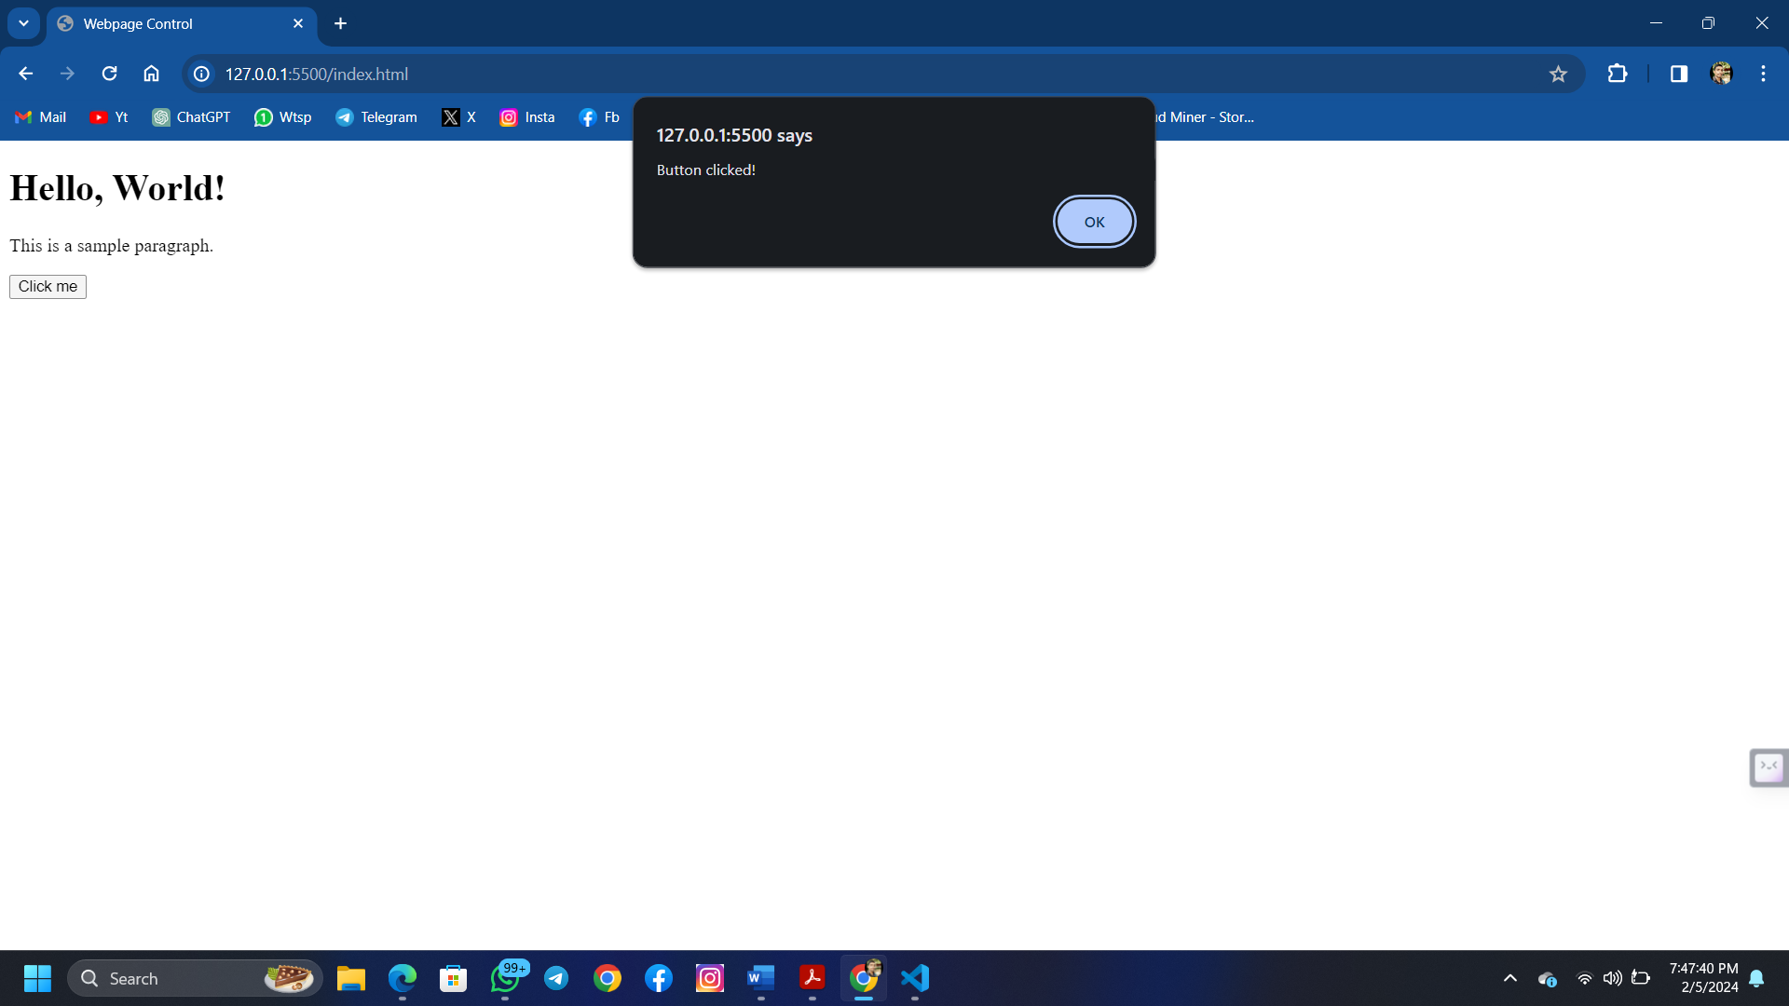

**Practical No: 5**

**AIM : Use Jquery library to apply different features on web pages.**

jQuery is a fast and lightweight JavaScript library that simplifies many common tasks in web development. To use jQuery in your web pages, follow these steps:

1. **Include jQuery Library:**

Include the jQuery library in the `<head>` section of your HTML document. You can either download jQuery and host it on your server or use a CDN (Content Delivery Network) link.

<!DOCTYPE html>

<html lang="en">

<head>

  <meta charset="UTF-8">

  <meta name="viewport" content="width=device-width, initial-scale=1.0">

  <!-- Using jQuery from a CDN -->

  <script src="https://code.jquery.com/jquery-3.6.0.min.js"></script>

  <title>Your Web Page</title>

</head>

<body>

  <!-- Your HTML content here -->

  <!-- jQuery scripts can be placed at the end of the body or in the head -->

</body>

</html>

1. **jQuery Basics:**

* **Selecting Elements:**

// Selecting elements by tag name

$('p').css('color', 'blue');

// Selecting elements by class

$('.highlight').css('background-color', 'yellow');

// Selecting elements by ID

$('#header').css('font-size', '24px');

* **Event Handling:**

// Click event

$('button').click(function() {

  alert('Button Clicked!');

});

// Hover event

$('div').hover(

  function() {

    $(this).css('background-color', 'lightgray');

  },

  function() {

    $(this).css('background-color', 'white');

  }

);

1. **Animation and Effects:**

* **Hide and Show:**

// Hide an element

$('p').hide();

// Show an element with animation

$('div').show(1000); // 1000 milliseconds (1 second) animation

* **Fade In and Out:**

// Fade out an element

$('img').fadeOut();

// Fade in an element with animation

$('h1').fadeIn(2000); // 2000 milliseconds (2 seconds) animation

* **Slide Up and Down:**

// Slide up an element

$('.box').slideUp();

// Slide down an element with animation

$('.menu').slideDown(1500); // 1500 milliseconds (1.5 seconds) animation

1. **AJAX (Asynchronous JavaScript and XML):**

* **Load Content:**

// Load content into an element

$('#result').load('content.html');

* **AJAX Request:**

// Perform an AJAX request

$.ajax({

  url: 'api/data',

  method: 'GET',

  success: function(data) {

    console.log(data);

  },

  error: function(error) {

    console.error(error);

  }

});

**Practical No: 6**

**AIM : Use Bootstrap library and icons to develop a responsive websites.**

Bootstrap is a popular front-end framework that makes it easy to create responsive and visually appealing websites. Bootstrap includes a variety of components and utilities for building responsive web pages. Additionally, you can use Bootstrap Icons to enhance the visual appeal of your website. Here's a simple example to get you started:

1. **Include Bootstrap CSS and JS:**

Start by including Bootstrap CSS and JS files in the `<head>` section of your HTML file. You can use the following CDN links:

<!DOCTYPE html>

   <html lang="en">

   <head>

       <meta charset="UTF-8">

       <meta name="viewport" content="width=device-width, initial-scale=1">

       <link href="https://cdn.jsdelivr.net/npm/bootstrap@5.3.0/dist/css/bootstrap.min.css" rel="stylesheet">

       <script src="https://cdn.jsdelivr.net/npm/bootstrap@5.3.0/dist/js/bootstrap.bundle.min.js"></script>

   </head>

   <body>

   <!-- Your content goes here -->

   </body>

   </html>

1. **Create a Responsive Navbar:**

Bootstrap makes it easy to create a responsive navbar. Here's a basic example:

<body>

       <nav class="navbar navbar-expand-lg navbar-light bg-light">

           <div class="container-fluid">

               <a class="navbar-brand" href="#">Your Logo</a>

               <button class="navbar-toggler" type="button" data-bs-toggle="collapse" data-bs-target="#navbarNav" aria-controls="navbarNav" aria-expanded="false" aria-label="Toggle navigation">

                   <span class="navbar-toggler-icon"></span>

               </button>

               <div class="collapse navbar-collapse" id="navbarNav">

                   <ul class="navbar-nav ml-auto">

                       <li class="nav-item">

                           <a class="nav-link" href="#">Home</a>

                       </li>

                       <li class="nav-item">

                           <a class="nav-link" href="#">About</a>

                       </li>

                       <li class="nav-item">

                           <a class="nav-link" href="#">Contact</a>

                       </li>

                   </ul>

               </div>

           </div>

       </nav>

       <!-- Your content goes here -->

   </body>

1. **Use Bootstrap Icons:**

You can easily integrate Bootstrap Icons into your project. Add the following link in the `<head>` section:

<link href="https://cdn.jsdelivr.net/npm/bootstrap-icons@1.18.0/font/bootstrap-icons.css" rel="stylesheet">

Then, use the icons in your HTML:

<i class="bi bi-house-door"></i> <!-- Example of a house icon -->

1. **Responsive Grid System:**

Use Bootstrap's grid system to create responsive layouts. For example:

<div class="container">

       <div class="row">

           <div class="col-md-6">

               <!-- Content for the first column -->

           </div>

           <div class="col-md-6">

               <!-- Content for the second column -->

           </div>

       </div>

   </div>

1. **Responsive Images:**

Bootstrap provides utility classes for responsive images:

<img src="your-image.jpg" class="img-fluid" alt="Responsive image">